**Unit 10 Volume Quiz**

*(22 points)*

*Show all work to receive credit*

1. *(3 points)*  
   1. 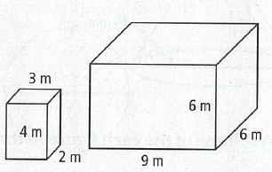What type of polyhedron is this?
   2. What is the volume of this polyhedron to the nearest unit?
2. *(3 points)*
   1. 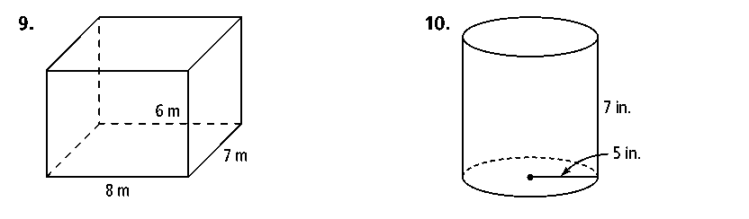What type of polyhedron is this?
   2. What is the volume of this polyhedron in terms of $π$?
3. *(3 points)*
   1. 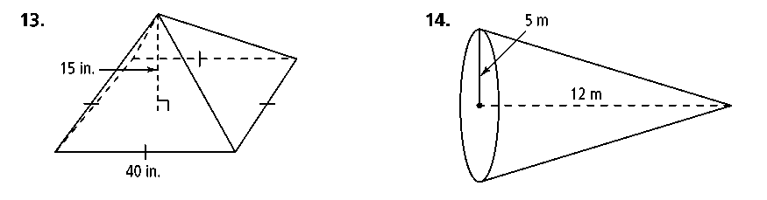What type of polyhedron is this?
   2. What is the volume of this polyhedron to the nearest thousandth?
4. *(3 points)*
5. 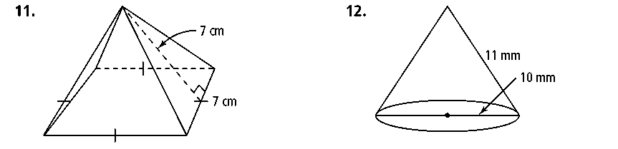What type of polyhedron is this?
6. What is the volume of this polyhedron in terms of $π$?
7. *(3 points)* Molly wishes to make a lawn ornament in the form of a solid sphere. The clay being used to make the sphere weighs .075 pound per cubic inch. If the sphere's radius is 10.16 cm, what is the weight of the sphere, to the nearest pound?
8. *(4 points)*
   1. 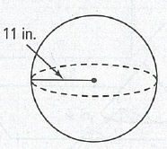Calculate the surface area of this sphere. Leave your answer in terms of .

* 1. Calculate the volume of this sphere. Leave your answer in terms of $π$.

1. *(3 points)* The circumference of a standard bowling ball is about 27 inches. To the nearest unit, how many square inches is the surface area of 100 bowling balls?